Implementation Notes — Login Page

Field | Value
Author | LiangJie Cheng — Developer 1
Date | 13 August 2026
Task | Task 4 — Style Login Page
Branch | feature/login-page-styling
Pull request | https://github.com/HudsonFurbank/Group-61-Mock-Sprint/pull/3

1. Purpose of this document
This document records how Task 4 (Style Login Page) was implemented, so BA/UX can validate the build against Login-Restyling-Design.docx, and so Dev 2 has the context needed to test it.

2. Task 4 — Style Login Page

What was done
- Applied the approved colours, spacing, and corner radius from the design doc to the login page
- Removed the Google sign-in button, per design decision #6 (no social sign-in, email/password only)
- Added a red banner for incorrect-credentials errors, matching the edge case table (wrong credentials vs field validation)
- Field-level validation errors still render under their respective field, unchanged from the original
Why: The design doc's scope for the login page is styling only — no fields added, removed, or reordered, and no change to authentication logic or session handling. All changes are visual or markup only; signInWithEmail, zodResolver, and loginSchema were not touched.

Sign In Page | Sign In Page - Edge Case

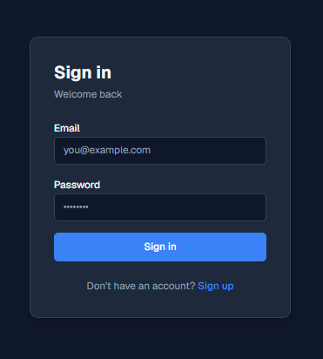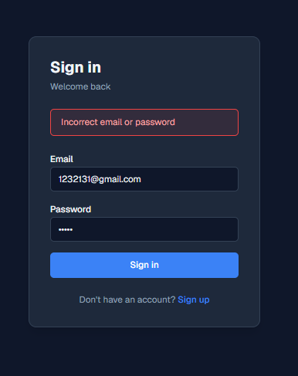

Files changed
- frontend/src/app/globals.css — added design tokens (surface-page, surface-card, surface-border, brand-500, text-primary, text-muted, error-border, error-text)
- frontend/src/app/(auth)/layout.tsx — background and login card max-width (360px) updated to match the design doc
- frontend/src/app/(auth)/auth/signin/page.tsx — card, inputs, button, and links restyled; Google sign-in removed; credential-error banner added

Known gaps and open items
- Design tokens are defined in globals.css under @theme and deliberately have no light-mode variant, because the design doc's palette is a fixed dark theme. If other pages still need light mode, this needs revisiting
- Only the sign-in page was restyled. The sign-up page still uses the original styling and was out of scope for Task 4

3. How to test
- Run npm run dev and open http://localhost:3000/auth/signin
- Compare against the login default mockup: dark navy background, 360px centred card, blue primary button, and no Google sign-in button
- Submit an invalid email format. A field-level error should appear under that field
- Submit a valid email with the wrong password. A red banner should appear above the form, matching the login error mock-up
- Submit valid credentials. Sign-in should succeed exactly as it did before the restyle

4. Verification
- Visually compared against Login-Restyling-Design.docx and the login and login error mock-ups
- Confirmed the incorrect-credentials banner appears on failed login, and field validation still appears per-field
- Confirmed no change to sign-in success or failure behaviour

5. BA sign-off
Field | Value
Reviewed by
Date
Outcome | Approved / Changes requested
Comments

